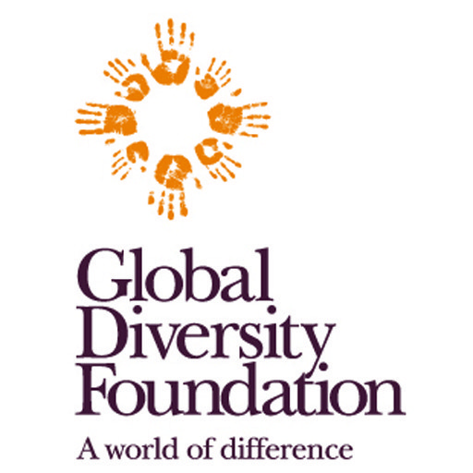
Job description

Position: Local Product Commercialisation Coordinator

Salary: to be determined based on experience

Location: Marrakech, Morocco
Start date: 1 July 2019

Organisation overview:
Global Diversity Foundation believes that our future depends on our respectful engagement with the vast biological and cultural diversity of Earth. We work to protect this diversity and enhance socio-ecological wellbeing. We carry out collaborative biocultural projects that build resilience, foster innovation and promote learning. Our work contributes to the growing global transition towards justice, respect and dignity for all beings.
We seek collaborators who are self-motivated to work autonomously within a horizontal structure to achieve mutually agreed outcomes in our environmental leadership and regional biocultural programmes. We value people who contribute innovative solutions to complex problems, work independently with minimum supervision and share results openly in a collaborative spirit, all while operating with the highest ethical and professional standards.

Background:
Global Diversity Foundation’s High Atlas Cultural Landscapes (HACL) Programme seeks to maintain the unique biocultural diversity of the Moroccan High Atlas. This diversity, and the iconic mountainous landscapes it is embedded in, have been maintained by local communities for millennia through local practices of land and resource management. Currently, this diversity and associated practices that sustain it are threatened by rural exodus, climate change, economic inequality and marginalisation. The HACL programme was established to provide an integrated approach to addressing these drivers. GDF and MBLA collaborate with local authorities and rural communities, as well as Moroccan government agencies, NGOs, academics and professionals, to implement our integrated agroecology-biodiversity-hydrology strategy that sustains communal and customary systems of decision-making, provides employment opportunities and promotes ecological restoration.
The HACL programme, supported by the UK Darwin Initiative, MAVA Foundation and Open Society Foundations, addresses the nexus between rural community livelihoods and biodiversity by supporting communities to better manage and conserve their valuable biodiversity by commercialising it sustainably and effectively through ethical, fair trade supply chains. In collaboration with an IUCN initiative on the socio-economic sustainability of cultural practices in selected Mediterranean cultural landscapes, we are documenting the market value chains of plant products, including essential oils distilled from valuable, threatened and endemic medicinal and aromatic plants and herbal teas, as well as honey, tree crops such as almonds and walnuts, and organic cereal products such as couscous. We focus on supply chains that reach high value niche markets in Marrakech, while not excluding international export markets.
The Local Products Commercialisation (LPC) Officer will be required to oversee the development of GDF/MBLA processes related to local product commercialisation and marketing, including design of a protocol and procedure for data consolidation and product selection, ethnobotanical monographs, feasibility studies for selected products, market value chain analysis, creation of draft business plans and their implementation. The LPC Officer will have the support of a team of botanists, ethnobotanists, plant ecologists and social scientists from GDF/MBLA, national and international consultants on the Local Product Commercialisation Expert Committee, and local researchers linked to community associations and producer cooperatives. He/she will collaborate with – and potentially consult for – a social enterprise, EthnoBotanica SARL, based at Jnane Tamsna Boutique Hotel and Organic Gardens in the Marrakech Palmeraie, to gain a deeper understanding of high value niche markets and the consumers who drive them.

Responsibilities:

General
- Understand the general context of local product commercialisation within the broader programme of work undertaken by GDF and MBLA by reading the grant proposals, reviewing background information provided by the team and participating in regular staff meetings;
- Develop an excellent understanding of existing protocols for assessing the viability and sustainability of local product commercialisation, including FairWild Certification assessment and monitoring tools (in particular for medicinal and aromatic plants) and emerging certification processes in Morocco;

Specific
- Design and implement – through rural and urban fieldwork – a protocol and procedure for analyzing local product commercialisation, including development of a product database, selection process, feasibility studies and market analyses, draft business plans and implementation plans for the sale of select species;
- Identify, inventory and interact with artisans, cooperatives, farmers, tourism operators and wild crafters based in the High Atlas region and urban-based green, natural resource and conservation entrepreneurs located in Marrakech and further afield;
- Develop an inventory of local products for sale through a social enterprise, engaging with consumers to provide information, assess demand, analyse price flexibility and document sales;
- Participate in the compilation of ethnobotanical monographs that consolidate diverse sources of information about specific plant products;
- Contribute to a deeper analysis of challenges and opportunities of local product commercialisation as well as of linkages between products and wider issues of cultural practices and sustainability in High Atlas landscapes;
- Explore the potential of connecting urban start-ups with rural entrepreneurs and conservation efforts in the High Atlas;
- Organise capacity-building workshops facilitated by external trainers and experts, and follow-up with cooperatives and rural social entrepreneurs to strengthen their administration, finance, decision-making and other skills, and to enhance their product development, marketing and sale capacities.

Team communications and reports
- Discuss project progress on a weekly basis with Gary Martin;
- Participate in bimonthly MBLA team meetings in Marrakech to update the team on progress, challenges and needs;
- Contribute to quarterly reporting as requested by the GDF Mediterranean Programme and Communications Coordinator;
- Maintain ongoing communications with the GDF/MBLA team through thematic WhatsApp groups;
- Contribute to GDF/MBLA communications and dissemination efforts.

Requirements for the role
Given the wide-ranging nature of the role, we are keen to recruit someone who enjoys both academic research and fieldwork – in rural and urban marketplaces and local communities. We are looking for an entrepreneurial ‘people-person’ who enjoys and is at ease engaging with many different kinds of people, from community producers to high-end consumers and international commercial buyers. We seek someone who is self-motivated and takes initiative, and who excels at spotting potential and seizing opportunities. A graduate or post-graduate with an entrepreneurial spirit and the desire to see commercial profits support sustainable development and community wellbeing would be an ideal fit.

Essential qualifications and/or skills
- Masters or PhD degree in relevant field (biology, business studies, economics, commerce, marketing, resource management, social sciences);
- Familiarity with business, social and market research, marketing, entrepreneurship and/or trade of rural products;
- Capacity to interact with cooperatives, national agricultural institutions, social entrepreneurs, high-end niche market consumers and other actors engaged in local product commercialisation;
- General knowledge of Moroccan trade regulations, and ability to rapidly learn more about wider policy and market contexts on the job;
- Willingness to travel as needed to marketplaces, High Atlas rural communities, urban retailers and other places in Morocco, and internationally for meetings and workshops;
- Commitment to explore high end niche markets in Marrakech and more generally in Morocco;
- Competence in maintaining inventory, bookkeeping and accounting related to local product commercialisation, and in developing relationships with community suppliers and niche market consumers;
- Ability to contribute to commercialization processes and management plans of local agricultural products;
- Initiative and self-motivation to work relatively autonomously while maintaining excellent communication and interaction with a team;
- Excellent oral and written skills in English and French;
- Fluency in Moroccan Arabic;
- Excellent entrepreneurial, interpersonal, leadership and motivational skills;
- Capacity to become an out-of-the-box, lateral thinker and opportunity-spotter with strong analytic skills;
- Excellent working knowledge of Microsoft Office package and database use;
- Ability to work in a multi-disciplinary and multi-cultural team;
- Commitment and drive to support biocultural diversity conservation and management;
- Understanding and acceptance of GDF values;

Desirable qualifications and/or skills
- Experience delivering capacity building activities, particularly among rural communities;
- Intermediate level in an Amazigh language, especially Tachelhit or Tamazight; competency in other languages
- A strong commitment to participatory approaches with rural communities;
experience working in a multicultural and/or international team.

How to apply:

Please submit a CV and cover letter (either in English or French) to Mediterranean Programme and Communications Coordinator Pommelien da Silva Cosme pommelien@global-diversity.org

Your cover letter should not exceed two pages and must clearly demonstrate how your skills, experience and knowledge meet the responsibilities and requirements of the role (as set out in the job description).

Deadline for applications: Ongoing
We are accepting applications on an ongoing basis until the position has been filled.

